Contents
1. INTRODUCTION AND PROJECT OVERVIEW 3
1.1 Project Context 3
1.2 Behavioral Patterns Overview 4
1.3 Deliverable Requirements Met 4
SECTION 2: TEMPLATE METHOD PATTERN CASES 5
2.1 TM1 — Template Method: Patient Discharge Workflow (Adham) 5
2.1.1 Problem Statement 5
2.1.2 Solution Design 6
2.1.3 Implementation Details 6
2.1.4 Why Template Method Pattern? 7
2.1.5 Demo Execution 7
2.2 TM2 — Template Method: Treatment Plan Process (Yassin) 8
2.2.1 Problem Statement 8
2.2.2 Solution Design 9
2.2.3 Implementation Details 9
2.2.4 Why Template Method Pattern? 10
2.2.5 Demo Execution 10
SECTION 3: MEDIATOR PATTERN CASES 11
3.1 MD1 — Mediator: Appointment Coordination System (Andrew) 11
3.1.1 Problem Statement 12
3.1.2 Solution Design 12
3.1.3 Implementation Details 12
3.1.4 Why Mediator Pattern? 13
3.1.5 Demo Execution 13
3.2 MD2 — Mediator: Emergency Response Coordination (Yassin) 14
3.2.1 Problem Statement 15
3.2.2 Solution Design 15
3.2.3 Implementation Details 15
3.2.4 Why Mediator Pattern? 16
3.2.5 Demo Execution 17
SECTION 4: STRATEGY PATTERN CASES 18
4.1 ST1 — Strategy: Billing Calculation Strategies (Adham) 18
4.1.1 Problem Statement 18
4.1.2 Solution Design 19
4.1.3 Implementation Details 19
4.1.4 Why Strategy Pattern? 20
4.1.5 Demo Execution 21
4.2 ST2 — Strategy: Payment Processing Strategies (Maged) 21
4.2.1 Problem Statement 22
4.2.2 Solution Design 22
4.2.3 Implementation Details 22
4.2.5 Demo Execution 23
SECTION 5: OBSERVER + SINGLETON PATTERN CASE (COMBINED) 24
5.1 OS1 — Observer + Singleton: Hospital Event System (Maged) 24
5.1.1 Problem Statement 24
5.1.2 Solution Design 24
5.1.3 Implementation Details 25
5.1.4 Why Observer + Singleton Pattern? 25
5.1.5 Demo Execution 26
SECTION 6: ITERATOR PATTERN CASE 27
6.1 IT1 — Iterator: Appointment Collection Traversal (Andrew) 27
6.1.1 Problem Statement 27
6.1.2 Solution Design 27
6.1.3 Implementation Details 28
6.1.4 Why Iterator Pattern? 28
6.1.5 Demo Execution 29
SECTION 7: DEVOPS AND PROJECT MANAGEMENT 30
7.1 Maven Configuration 30
7.2 Git Repository Structure and Branch Rules (B0) 31
7.3 JIRA Project Management (B1) 31
SECTION 8: ASSUMPTIONS AND DESIGN DECISIONS 31
8.1 Assumptions Made 31
8.2 Design Decisions 32
8.3 Report Formatting and Consistency Rules (M0) 33
SECTION 9: CONCLUSION 33
9.1 Summary of Deliverable #3 33

1. INTRODUCTION AND PROJECT OVERVIEW

1.1 Project Context

The Hospital Management System (HMS) is a comprehensive software solution designed to manage patient workflows, appointments, billing, notifications, and emergency response. In Deliverable #3, we enhance system flexibility and maintainability by applying behavioral design patterns to realistic hospital scenarios.
The system now integrates 8 pattern implementations covering all required behavioral patterns: Template Method, Mediator, Strategy, Observer+Singleton, and Iterator.

1.2 Behavioral Patterns Overview

Behavioral design patterns focus on algorithms, responsibility assignment, and object collaboration. These deliverable implements:
• 2 Template Method cases to standardize workflows with controlled variations.
• 2 Mediator cases to reduce coupling through centralized component coordination.
• 2 Strategy cases to enable interchangeable behaviors selected at runtime.
• 1 Observer + Singleton combined case for event-driven updates via a global event source.
• 1 Iterator case for safe collection traversal without exposing internal structure.

1.3 Deliverable Requirements Met

Requirements Status Table
Requirement | Status | Evidence
2 Template Method cases implemented | COMPLETE | TM1: Section 2.1, UML  TM2: Section 2.2, UML
2 Mediator cases implemented | COMPLETE | MD1: Section 3.1, UML  MD2: Section 3.2, UML
2 Strategy cases implemented | COMPLETE | ST1: Section 4.1, UML  ST2: Section 4.2, UML
Observer + Singleton combined case | COMPLETE | OS1: Section 5.1, UML
Iterator case implemented | COMPLETE | IT1: Section 6.1, UML
Maven project builds successfully | COMPLETE | Figure 7.1: BUILD SUCCESS
Demos run without errors | COMPLETE | Options 15–22 verified
JIRA timeline with dependencies | COMPLETE | Figure 7.3: Jira Board

Pattern Coverage Table
Pattern | Required | Case IDs | Owner(s) | Status
Template Method | 2 | TM1, TM2 | Adham, Yassin | COMPLETE
Mediator | 2 | MD1, MD2 | Andrew, Yassin | COMPLETE
Strategy | 2 | ST1, ST2 | Adham, Maged | COMPLETE
Observer + Singleton | 1 | OS1 | Maged | COMPLETE
Iterator | 1 | IT1 | Andrew | COMPLETE

================================================================================

SECTION 2: TEMPLATE METHOD PATTERN CASES
================================================================================

2.1 TM1 — Template Method: Patient Discharge Workflow (Adham)

Traceability: Requirement: Template Method (2 cases) → TM1, TM2

2.1.1 Problem Statement
The HMS discharge workflow follows a strict multi-step sequence: validation, medical clearance verification, final billing calculation, discharge document generation, and stakeholder notification. Different discharge types (standard vs emergency) require variations in specific steps—notably billing settlement rules and medical clearance urgency. Without a structured pattern, discharge logic becomes duplicated across classes or cluttered with conditional logic, reducing maintainability and making it difficult to add new discharge variants safely.

2.1.2 Solution Design
We apply the Template Method pattern by defining the discharge algorithm skeleton in an abstract class DischargeProcessTemplate. The method executeDischarge() defines the fixed workflow order, while subclasses StandardDischargeProcess and EmergencyDischargeProcess override only the variable steps:
• verifyMedicalClearance() — standard requires full clearance; emergency uses expedited path
• calculateFinalCharges() — different admin/emergency fees
• settlePayment() — standard settles immediately; emergency allows deferred billing

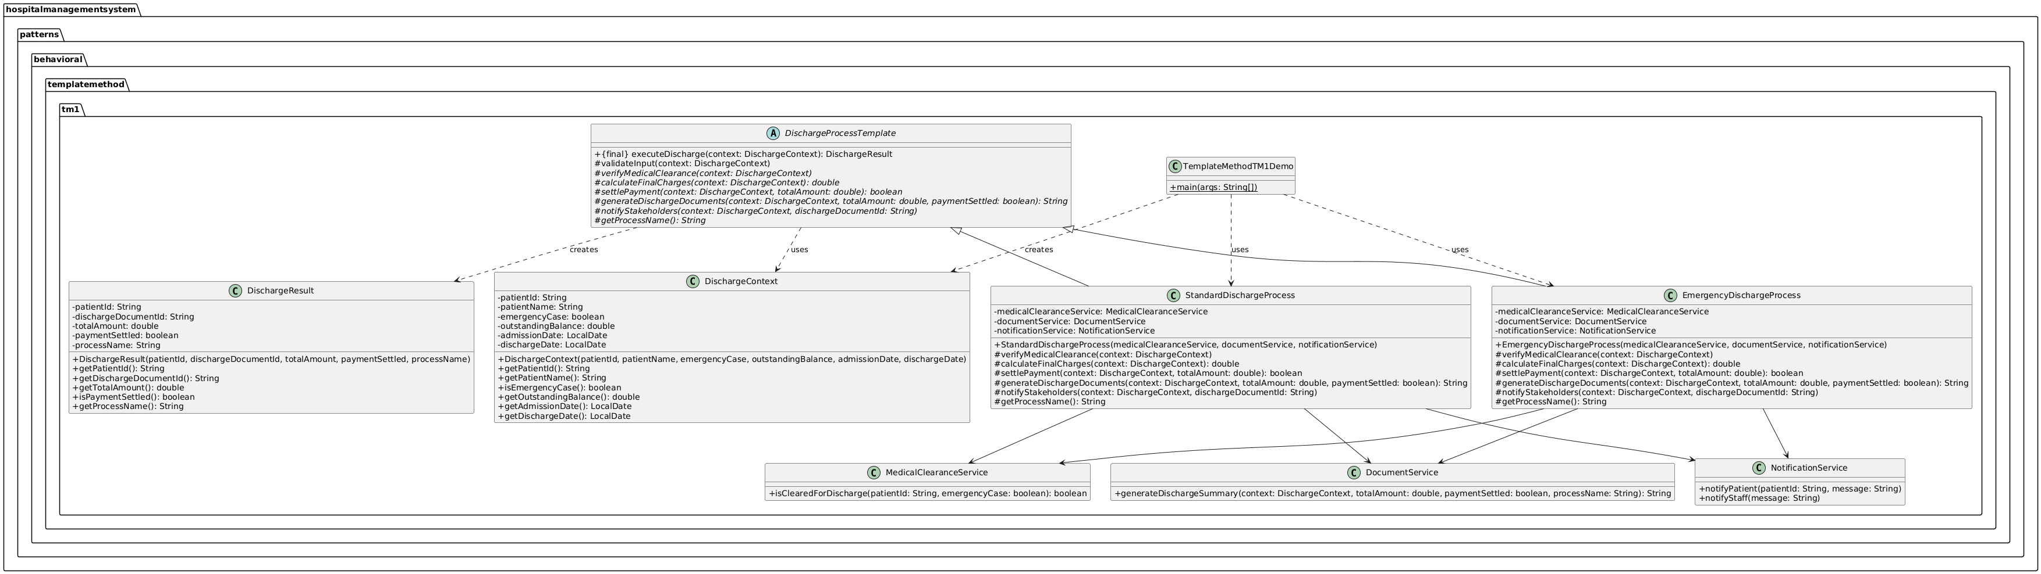

2.1.3 Implementation Details
Location: hospitalmanagementsystem.patterns.behavioral.templatemethod.tm1
Key Classes:
• DischargeProcessTemplate — Abstract template (algorithm skeleton)
• StandardDischargeProcess, EmergencyDischargeProcess — Concrete implementations
• DischargeContext — Input context (patient info, dates, balance, emergency flag)
• DischargeResult — Output result (document ID, total amount, payment status)
• MedicalClearanceService, DocumentService, NotificationService — Supporting services
• TemplateMethodTM1Demo — Client demonstration class
Role Mapping:
• DischargeProcessTemplate → AbstractClass
• executeDischarge() → templateMethod() (final, defines algorithm order)
• verifyMedicalClearance(), calculateFinalCharges(), settlePayment(), generateDischargeDocuments(), notifyStakeholders() → primitiveOperations/hooks
• StandardDischargeProcess / EmergencyDischargeProcess → ConcreteClass
• DischargeContext → Context/Data
• TemplateMethodTM1Demo → Client

2.1.4 Why Template Method Pattern?
• Enforces consistent workflow: All discharge types follow the same step sequence, preventing skipped steps or out-of-order execution.
• Reduces duplication: Common steps are implemented once in the abstract template.
• Supports Open/Closed Principle: New discharge types added via new subclasses.
• Isolates variations: Each variant's unique behavior is in its own class.

2.1.5 Demo Execution

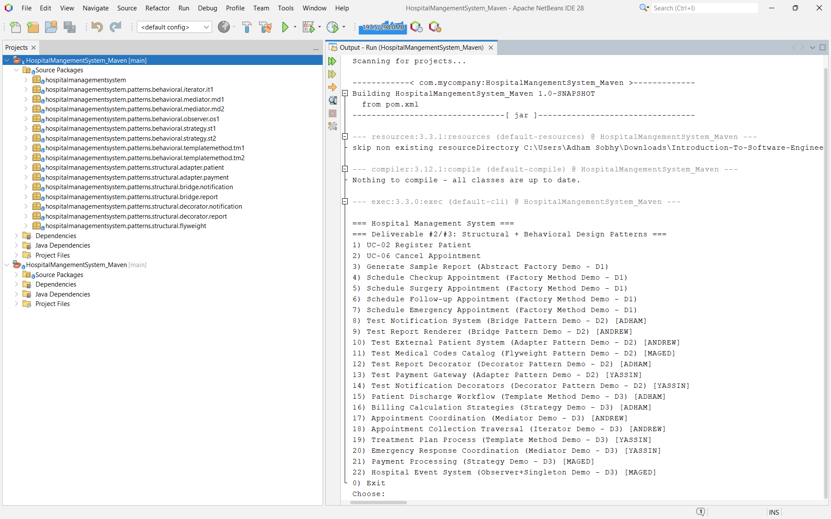
Run Configuration:
• Class: hospitalmanagementsystem.HospitalMangementSystem
• Menu Option: 15
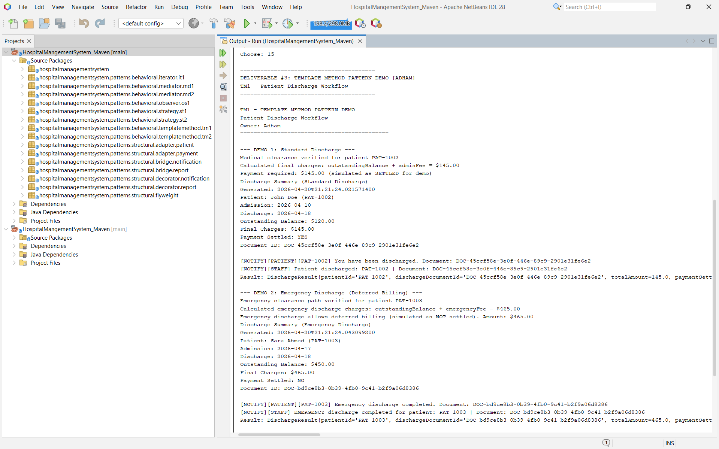
Proved Behavior:
• Demo 1: Standard discharge with payment settled, document generated, notifications sent.
• Demo 2: Emergency discharge with deferred billing, expedited clearance path.
• Both execute the same workflow sequence with controlled variations.

2.2 TM2 — Template Method: Treatment Plan Process (Yassin)

Traceability: Requirement: Template Method (2 cases) → TM1, TM2

2.2.1 Problem Statement
Hospital treatment plans follow a standardized process: patient assessment, diagnosis confirmation, treatment selection, treatment execution, and post-treatment follow-up. However, different patient categories (Inpatient, Outpatient, Emergency) require variations in specific steps. Without a structured pattern, treatment logic becomes duplicated or cluttered with conditional branches, reducing maintainability and making it difficult to add new treatment plan types safely.

2.2.2 Solution Design
We apply the Template Method pattern by defining the treatment plan algorithm skeleton in an abstract class TreatmentPlanTemplate. The method createTreatmentPlan() defines the fixed workflow order, while subclasses InpatientTreatmentPlan, OutpatientTreatmentPlan, and EmergencyTreatmentPlan override only the variable steps:
• assessPatientCondition() — different assessment protocols for each type
• confirmDiagnosis() — standard diagnosis vs expedited for emergency
• selectTreatment() — treatment options vary by patient category
• executeTreatment() — inpatient requires admission, outpatient does not
• scheduleFollowUp() — follow-up intervals differ by treatment type
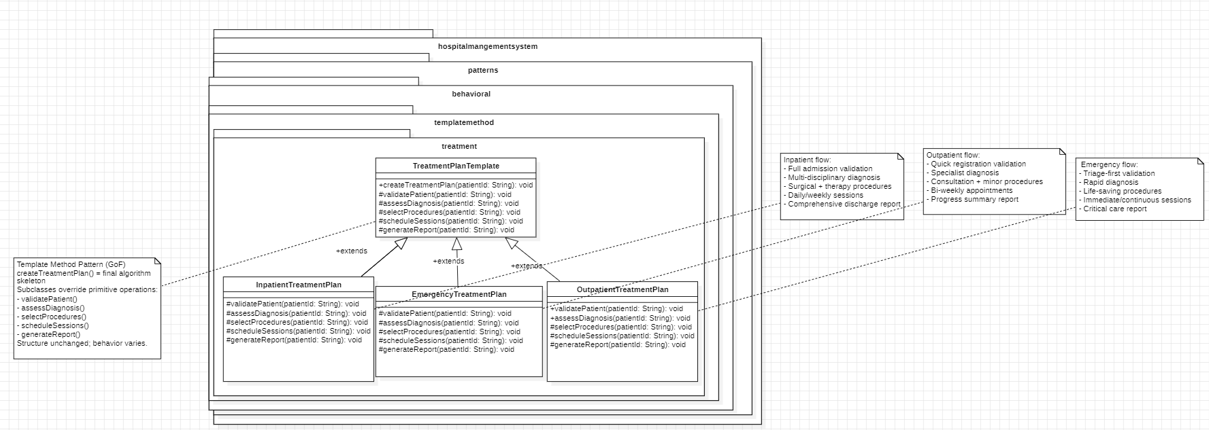

2.2.3 Implementation Details
Location: hospitalmanagementsystem.patterns.behavioral.templatemethod.tm2
Key Classes:
• TreatmentPlanTemplate — Abstract template defining the algorithm skeleton
• InpatientTreatmentPlan — Concrete implementation for admitted patients
• OutpatientTreatmentPlan — Concrete implementation for day patients
• EmergencyTreatmentPlan — Concrete implementation for urgent cases
• TreatmentPlanDemo — Client demonstration class
Role Mapping:
• TreatmentPlanTemplate → AbstractClass
• createTreatmentPlan() → templateMethod() (final, defines algorithm order)
• assessPatientCondition(), confirmDiagnosis(), selectTreatment(), executeTreatment(), scheduleFollowUp() → primitiveOperations/hooks
• InpatientTreatmentPlan / OutpatientTreatmentPlan / EmergencyTreatmentPlan → ConcreteClass
• TreatmentPlanDemo → Client

2.2.4 Why Template Method Pattern?
• Enforces standardized care protocols: All treatment plans follow the same medical workflow sequence, preventing skipped critical steps.
• Reduces code duplication: Common steps (documentation, patient verification) are implemented once in the abstract template.
• Supports specialization: New patient categories can be added by creating new subclasses without modifying existing templates.
• Improves patient safety: Template structure ensures consistent quality of care across all treatment types.
• Why not if/else: Large conditional blocks for treatment types would create tight coupling and make it difficult to add new treatment categories.

2.2.5 Demo Execution
SS
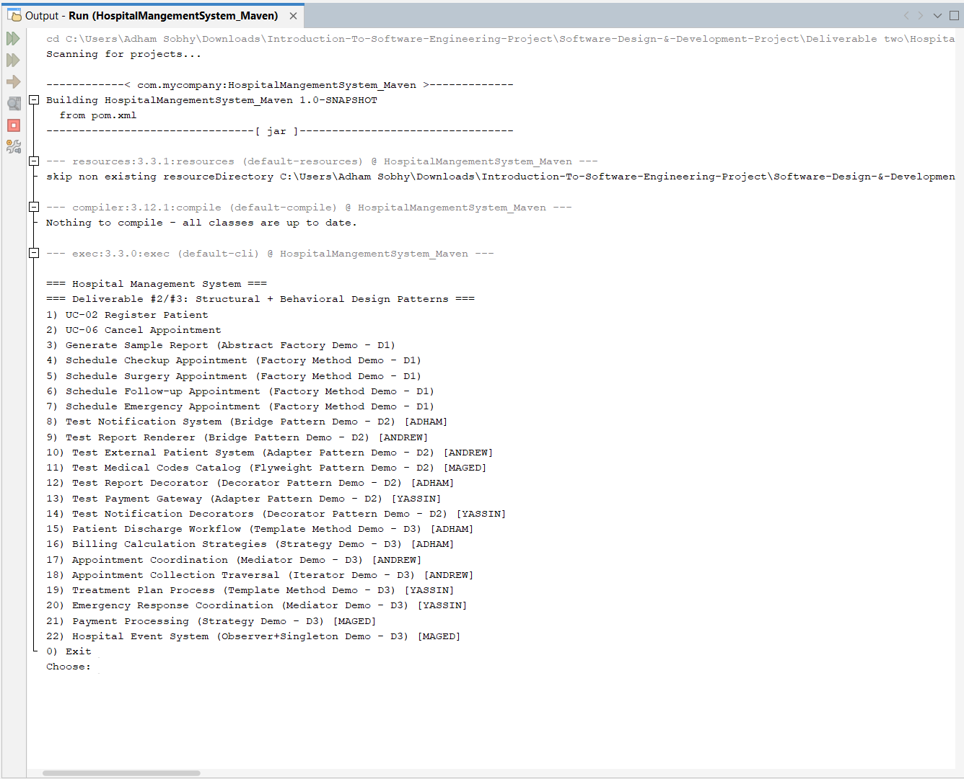
Run Configuration:
• Class: hospitalmanagementsystem.HospitalMangementSystem
• Menu Option: 19
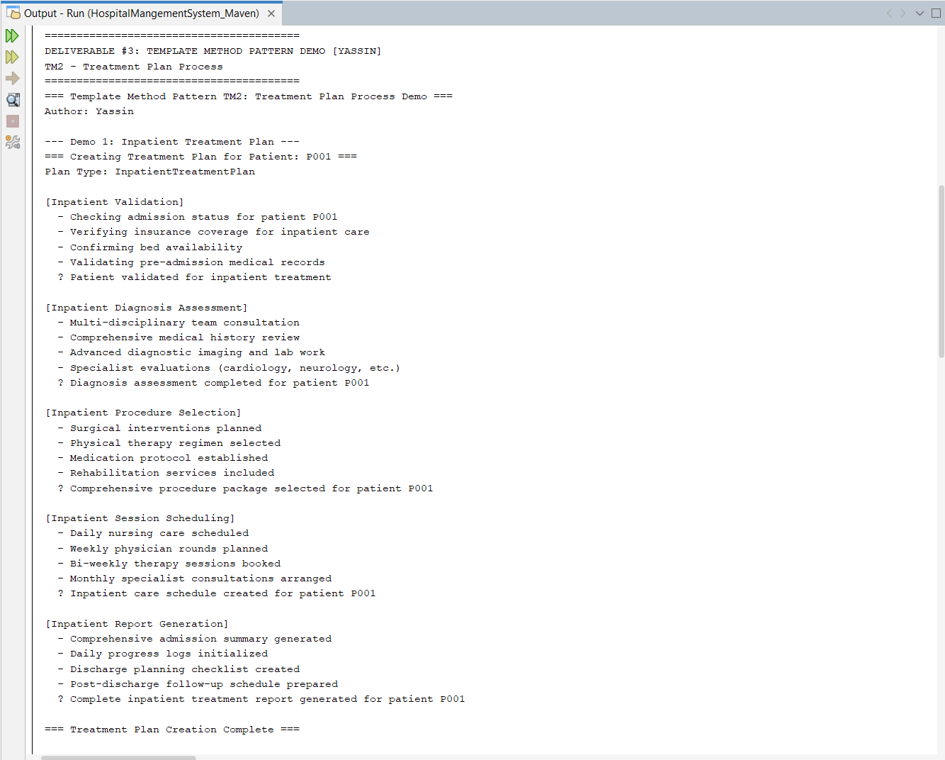
Proved Behavior:
• Demo 1: Inpatient treatment plan shows admission procedures, room assignment, and multi-day treatment with post-discharge follow-up.
• Demo 2: Outpatient treatment plan demonstrates same-day procedures with minimal facility usage and standard follow-up.
• Demo 3: Emergency treatment plan displays expedited assessment, immediate treatment execution, and urgent stabilization protocols.
• All three demos execute the same algorithm structure while demonstrating controlled variations appropriate to each patient category.

SECTION 3: MEDIATOR PATTERN CASES

3.1 MD1 — Mediator: Appointment Coordination System (Andrew)

Traceability: Requirement: Mediator (2 cases) → MD1, MD2

3.1.1 Problem Statement
Hospital appointment scheduling involves multiple interacting components: patients requesting appointments, doctors providing availability, rooms needing allocation, and notifications requiring dispatch. Without a centralized coordinator, these components form tight coupling with direct references to each other. Any change in one component requires modifications in others, creating a maintenance nightmare and increasing regression risk.

3.1.2 Solution Design
We apply the Mediator pattern by introducing an AppointmentCoordinator that acts as the central hub for all appointment-related communications. Components (Patient, Doctor, Room, NotificationService) communicate only through the mediator, not directly with each other:
• Patient requests appointment → Mediator coordinates with Doctor and Room
• Doctor updates availability → Mediator notifies waiting Patients
• Room becomes available → Mediator allocates to pending appointments
• Appointment scheduled → Mediator triggers notifications
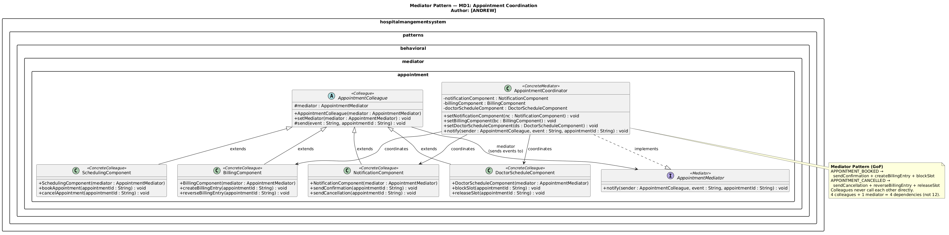

3.1.3 Implementation Details
Location: hospitalmanagementsystem.patterns.behavioral.mediator.md1
Key Classes:
• AppointmentMediator — Mediator interface defining communication contract
• AppointmentCoordinator — ConcreteMediator managing component interactions
• Colleague — Abstract base class for components
• Patient, Doctor, Room, NotificationService — ConcreteColleague classes
• AppointmentMediatorDemo — Client demonstration class
Role Mapping:
• AppointmentMediator → Mediator
• AppointmentCoordinator → ConcreteMediator
• Colleague → Colleague (abstract base)
• Patient, Doctor, Room, NotificationService → ConcreteColleague
• registerColleague(), notify() → Mediator communication methods
• send() → Colleague-to-mediator communication
• AppointmentMediatorDemo → Client

3.1.4 Why Mediator Pattern?
• Reduces coupling: Components don't reference each other directly, only the mediator. Changes to one component don't cascade to others.
• Centralizes control: Complex interaction logic lives in one place (mediator), making it easier to understand and modify.
• Simplifies component reuse: Individual colleagues can be reused in other contexts without their specific interaction baggage.
• Supports many-to-many relationships: One mediator can coordinate many components without creating an explosion of direct connections.
• Why not direct communication: N-to-N direct connections would create O(n²) complexity and make the system unmaintainable.

3.1.5 Demo Execution
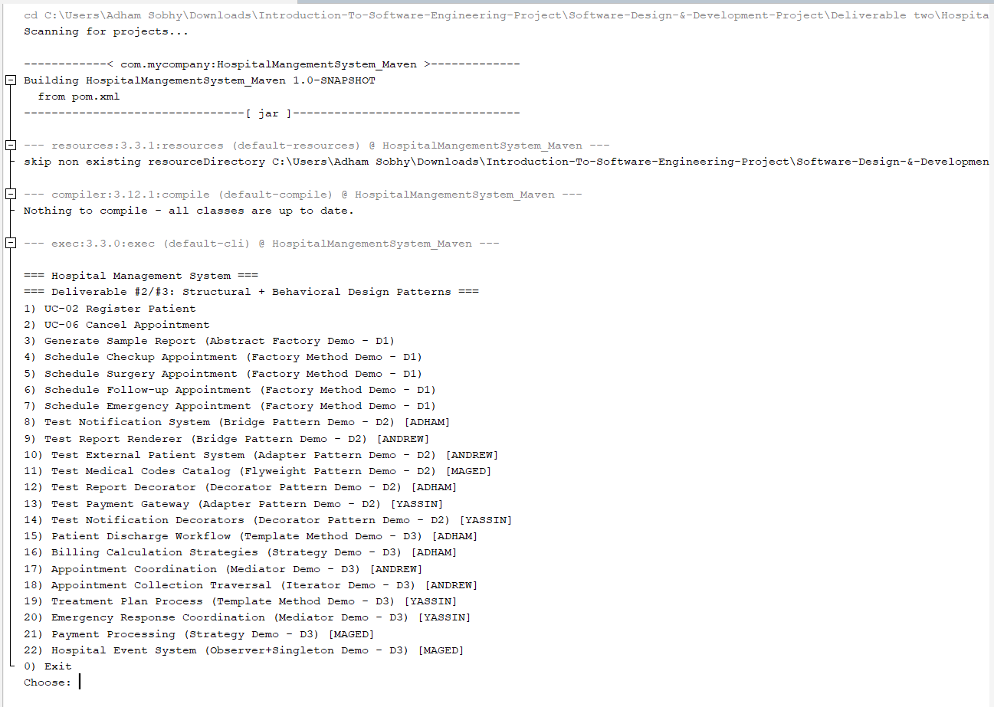
Run Configuration:
• Class: hospitalmanagementsystem.HospitalMangementSystem
• Menu Option: 17
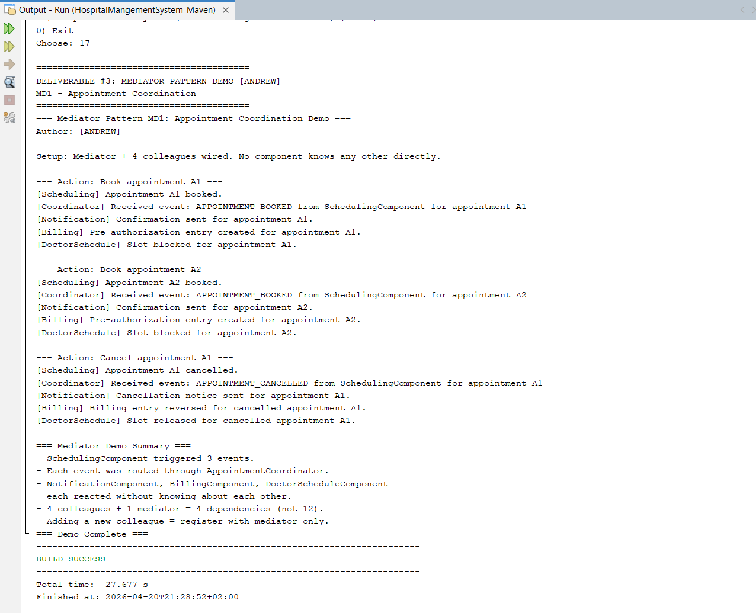
Proved Behavior:
• Demo 1: Patient requests appointment → Mediator checks doctor availability and room status → Coordinates scheduling → Triggers notifications.
• Demo 2: Doctor updates schedule → Mediator updates availability → Notifies waiting patients automatically.
• Demo 3: Multiple appointment requests demonstrate mediator managing concurrent coordination without component-to-component coupling.
• Components interact only through mediator, demonstrating loose coupling.

3.2 MD2 — Mediator: Emergency Response Coordination (Yassin)

Traceability: Requirement: Mediator (2 cases) → MD1, MD2

3.2.1 Problem Statement
Hospital emergency response requires coordinated action from multiple departments: triage assessment, medical teams, facilities preparation, and communication systems. During emergencies, these components must react quickly and in coordination. Without a centralized coordinator, emergency response becomes chaotic with delayed notifications, missed preparations, and uncoordinated actions, potentially endangering patient safety.

3.2.2 Solution Design
We apply the Mediator pattern by introducing an EmergencyCoordinator that orchestrates emergency response across all components:
• TriageComponent detects emergency → Notifies Mediator
• Mediator coordinates MedicalComponent, FacilitiesComponent, CommunicationComponent
• MedicalComponent prepares emergency team
• FacilitiesComponent prepares equipment and rooms
• CommunicationComponent notifies staff and updates displays
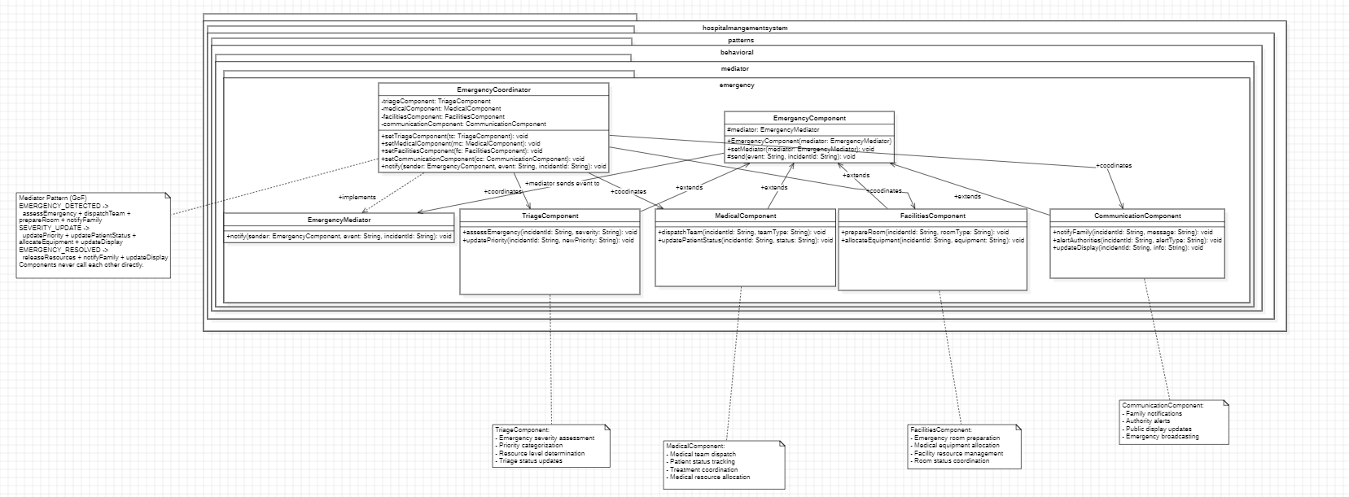

3.2.3 Implementation Details
Location: hospitalmanagementsystem.patterns.behavioral.mediator.md2
Key Classes:
• EmergencyMediator — Mediator interface
• EmergencyCoordinator — ConcreteMediator managing emergency coordination
• EmergencyComponent — AbstractColleague base class
• TriageComponent — Detects and reports emergency conditions
• MedicalComponent — Prepares medical response teams
• FacilitiesComponent — Prepares equipment and rooms
• CommunicationComponent — Broadcasts alerts and updates
• EmergencyMediatorDemo — Client demonstration class
Role Mapping:
• EmergencyMediator → Mediator
• EmergencyCoordinator → ConcreteMediator
• EmergencyComponent → Colleague (abstract)
• TriageComponent, MedicalComponent, FacilitiesComponent, CommunicationComponent → ConcreteColleague
• notify(), registerComponent() → Mediator methods
• sendEvent() → Colleague-to-mediator communication
• EmergencyMediatorDemo → Client

3.2.4 Why Mediator Pattern?
• Centralizes emergency coordination: All emergency response logic flows through one coordinator, ensuring consistent and complete response.
• Reduces emergency response time: Components react to mediator notifications rather than polling or waiting for direct communication.
• Prevents missed actions: Mediator ensures all components receive relevant notifications based on event type.
• Improves safety: Structured coordination prevents gaps in emergency response that could endanger patients.
• Why not broadcast messaging: Unmediated broadcasts would create noise and potentially miss critical coordination steps.

3.2.5 Demo Execution
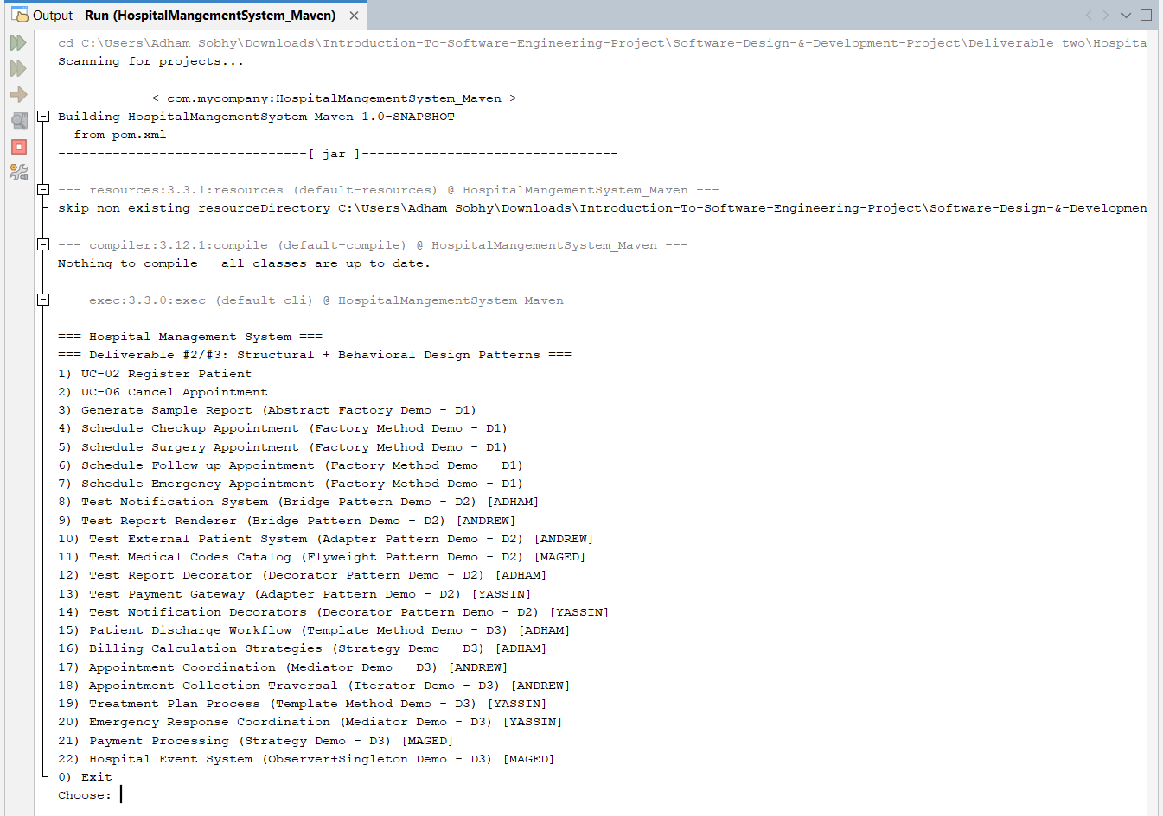
Run Configuration:
• Class: hospitalmanagementsystem.HospitalMangementSystem
• Menu Option: 20
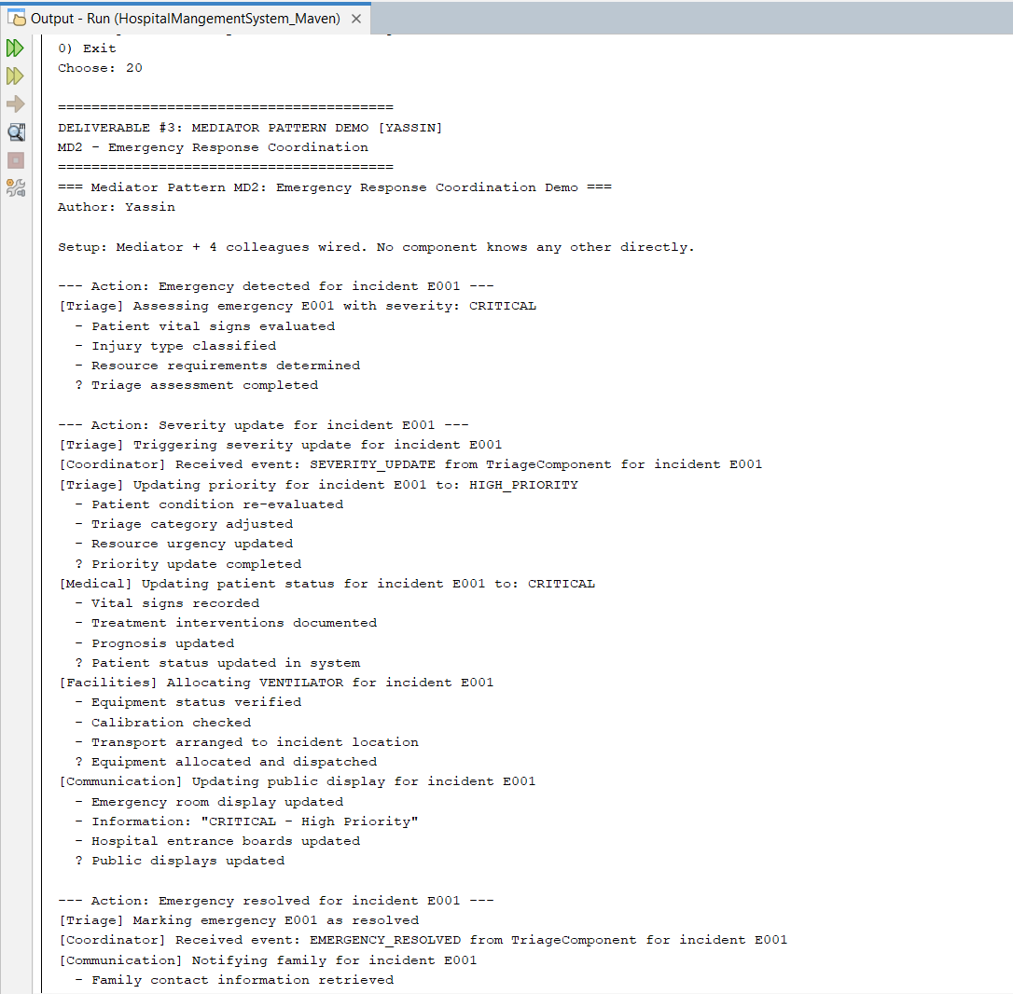
Proved Behavior:
• Demo 1: TriageComponent detects critical patient → Mediator coordinates medical team preparation, facilities readiness, and staff notification.
• Demo 2: Mass casualty event simulation shows mediator managing multiple simultaneous emergency responses across all departments.
• Demo 3: Emergency escalation demonstrates mediator updating communication systems and reallocating resources dynamically.
• All demos show coordinated, complete emergency response through centralized mediator control.

SECTION 4: STRATEGY PATTERN CASES

4.1 ST1 — Strategy: Billing Calculation Strategies (Adham)

Traceability: Requirement: Strategy (2 cases) → ST1, ST2

4.1.1 Problem Statement
Billing logic in HMS varies based on patient conditions and business policies: standard billing, insurance coverage (with varying percentages), and senior citizen discounts. Implementing these variations using large conditional blocks (if/else) would create a rigid, unmaintainable structure where adding new billing policies requires modifying existing code—violating the Open/Closed Principle and increasing regression risk.

4.1.2 Solution Design
We apply the Strategy pattern by defining a BillingStrategy interface that encapsulates billing calculation algorithms. The BillingCalculator (Context) holds a reference to a BillingStrategy and delegates calculation to it. This enables runtime strategy switching without modifying the calculator.
Three concrete strategies:
• StandardBillingStrategy — no discounts, full amount payable
• InsuranceBillingStrategy — covers percentage of bill based on insurance plan
• SeniorDiscountBillingStrategy — applies age-based discount for patients 65+
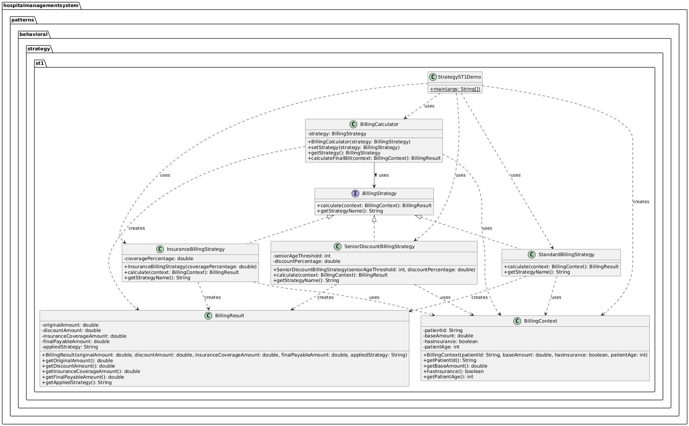

4.1.3 Implementation Details
Location: hospitalmanagementsystem.patterns.behavioral.strategy.st1
Key Classes:
• BillingStrategy — Strategy interface
• StandardBillingStrategy, InsuranceBillingStrategy, SeniorDiscountBillingStrategy — Concrete strategies
• BillingCalculator — Context (holds strategy reference)
• BillingContext — Input data
• BillingResult — Output data
• StrategyST1Demo — Client demonstration class
Role Mapping:
• BillingStrategy → Strategy
• Concrete strategy classes → ConcreteStrategy
• BillingCalculator → Context
• setStrategy() → strategy setting method
• BillingContext, BillingResult → Data/Parameter objects
• StrategyST1Demo → Client

4.1.4 Why Strategy Pattern?
• Eliminates conditional complexity: No if/else chains for billing rules.
• Enables runtime flexibility: Strategy selected/changed at runtime.
• Supports Open/Closed Principle: New policies added via new classes.
• Improves testability: Each strategy unit tested independently.
• Why not if/else: Large conditional blocks would violate OCP and create maintenance burden.

4.1.5 Demo Execution
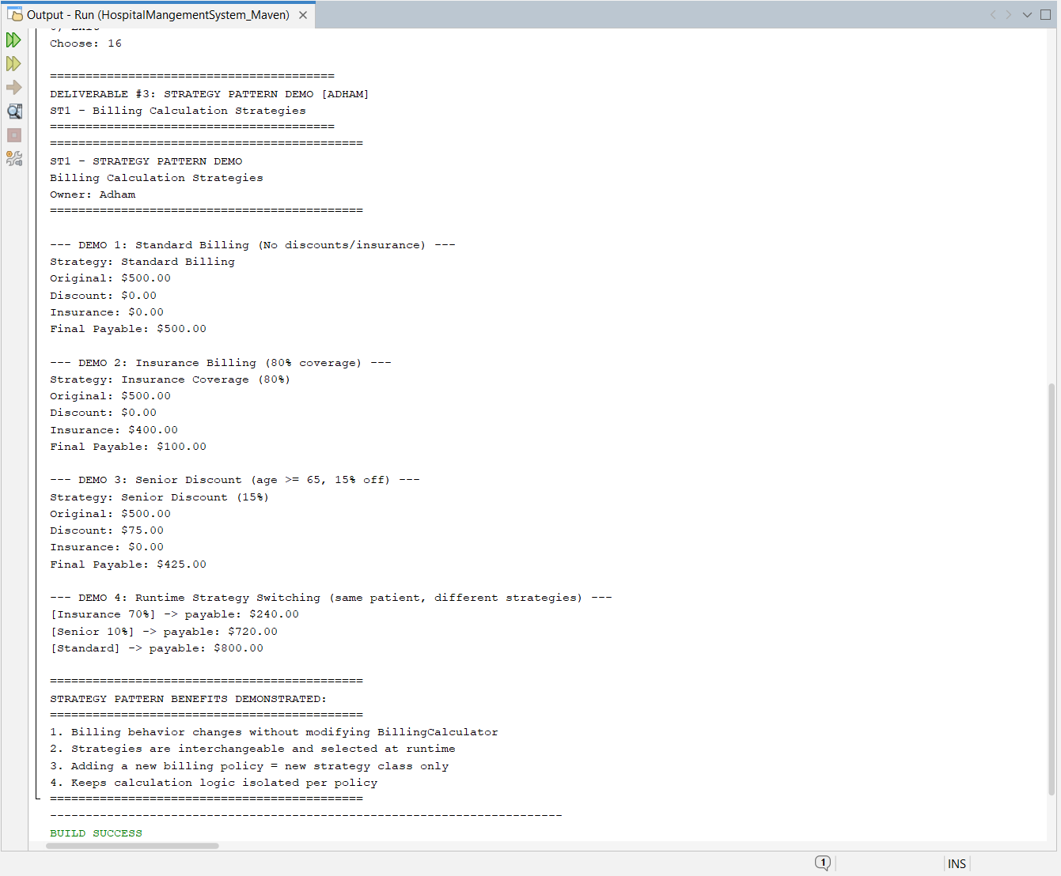
Run Configuration:
• Class: hospitalmanagementsystem.HospitalMangementSystem
• Menu Option: 16
Proved Behavior:
• Demo 1: Standard billing — $500.00 base produces $500.00 payable.
• Demo 2: Insurance billing (80% coverage) — $500.00 → $100.00 patient payable.
• Demo 3: Senior discount (15% for age 65+) — $500.00 → $425.00 payable.
• Demo 4: Runtime switching — Same patient processed with three different strategies sequentially, showing different payable amounts.

4.2 ST2 — Strategy: Payment Processing Strategies (Maged)

Traceability: Requirement: Strategy (2 cases) → ST1, ST2

4.2.1 Problem Statement
Hospital billing requires flexible payment processing to accommodate different patient preferences and financial situations. Payment methods include cash (upfront), insurance (claims processing), and credit card (instant processing). Each method has distinct validation, processing, and confirmation steps. Without a structured pattern, payment logic becomes scattered with conditional branches throughout the codebase, making it difficult to add new payment methods or modify existing ones without affecting unrelated code.

4.2.2 Solution Design
We apply the Strategy pattern by defining a PaymentStrategy interface that encapsulates payment processing algorithms. The BillingContext (Context) maintains patient, doctor, and appointment information while delegating payment execution to the selected strategy:
• CashPayment — Validates cash amount, processes immediate payment, generates receipt
• InsurancePayment — Validates insurance coverage, submits claim, processes approval/denial
• CreditCardPayment — Validates card details, processes charge, handles transaction confirmation

4.2.3 Implementation Details
Location: hospitalmanagementsystem.patterns.behavioral.strategy.st2
Key Classes:
• PaymentStrategy — Strategy interface (pay(), validate())
• CashPayment — ConcreteStrategy for cash transactions
• InsurancePayment — ConcreteStrategy for insurance claims
• CreditCardPayment — ConcreteStrategy for credit card charges
• BillingContext — Context managing patients, doctors, appointments
• Patient — Domain model (id, name, age, insuranceProvider)
• Doctor — Domain model (id, name, specialty, consultationFee)
• Appointment — Domain model with status tracking
• AppointmentStatus — Enum (PENDING, CONFIRMED, CANCELLED, COMPLETED)
• PaymentStrategyDemo — Client demonstration class
Role Mapping:
• PaymentStrategy → Strategy
• CashPayment, InsurancePayment, CreditCardPayment → ConcreteStrategy
• BillingContext → Context
• setPaymentStrategy() → strategy setting method (runtime switching)
• Patient, Doctor, Appointment → Domain objects used by context
• PaymentStrategyDemo → Client
4.2.4 Why Strategy Pattern?
• Encapsulates payment algorithms: Each payment method is isolated in its own class with clear validation and processing logic.
• Enables payment flexibility: Patients can switch payment methods at checkout without changing the billing system structure.
• Supports financial compliance: Different payment types (insurance claims vs. cash) have distinct audit and compliance requirements.
• Simplifies payment extension: New payment methods (mobile payments, payment plans) added by creating new strategy classes.
• Why not switch statements: Conditional payment logic would scatter across multiple classes and create tight coupling between billing and payment types.

4.2.5 Demo Execution
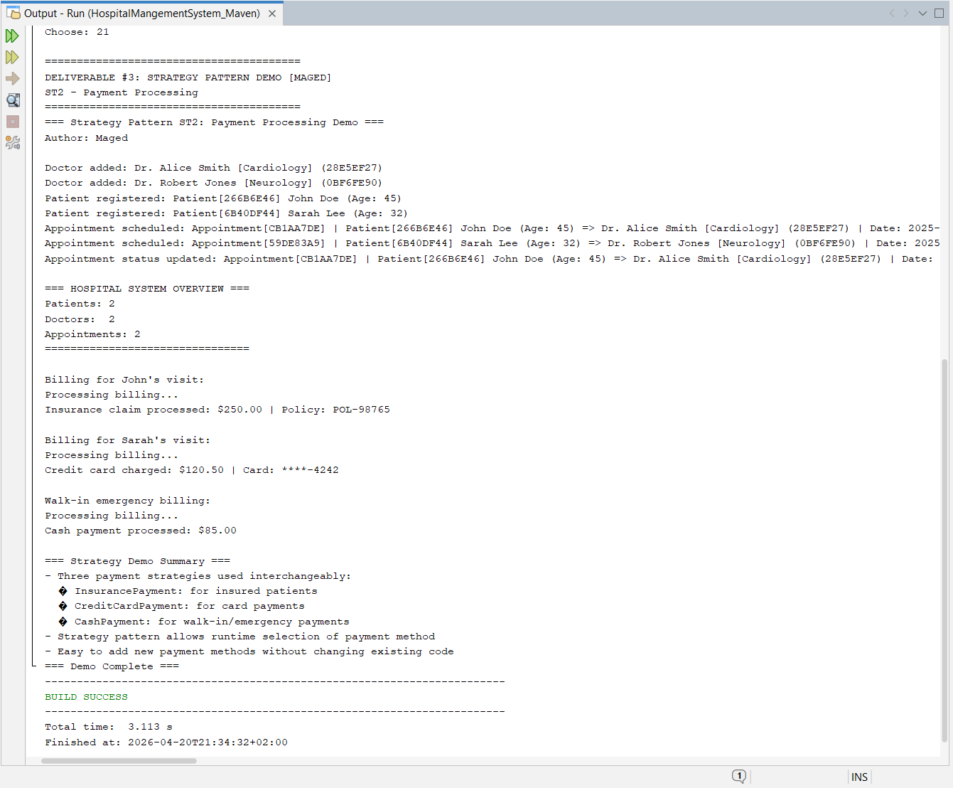
Run Configuration:
• Class: hospitalmanagementsystem.HospitalMangementSystem
• Menu Option: 21
Proved Behavior:
• Demo 1: Cash payment — $500 appointment processed with immediate payment confirmation and receipt generation.
• Demo 2: Insurance payment — $1500 surgery claim submitted to BlueCross, processed with approval confirmation and policy reference.
• Demo 3: Credit card payment — $300 consultation charged to card ending 4848, with transaction ID and confirmation.
• Demo 4: Runtime switching — Same patient appointment processed sequentially with all three payment methods, demonstrating strategy interchangeability.
• All demos show proper validation, processing, and status updates for each payment strategy.
================================================================================

SECTION 5: OBSERVER + SINGLETON PATTERN CASE (COMBINED)

5.1 OS1 — Observer + Singleton: Hospital Event System (Maged)

Traceability: Requirement: Observer + Singleton (1 combined case) → OS1

5.1.1 Problem Statement
Hospital operations generate numerous events requiring notification to multiple stakeholders: patient status changes, lab results availability, bed availability updates, appointment scheduling, and emergency alerts. Different staff members (doctors, nurses, lab technicians, admin staff) need to receive only events relevant to their role and department. Without a structured pattern, event notification becomes chaotic with direct coupling between event sources and listeners, making it impossible to add new event types or subscribers without modifying existing code. Additionally, having multiple event notification systems would create inconsistency and missed events.

5.1.2 Solution Design
We apply a combined Observer + Singleton pattern:
• Singleton: HospitalEventBus — Single global event source ensuring all events flow through one consistent channel
• Observer: EventListener interface — Components subscribe to specific event types and departments
• Concrete Observers: Doctor, Nurse, LabTechnician, AdminStaff — Each implements event handling with filtering based on role and department
Event filtering:
• Doctors receive: LAB_RESULTS_READY, PATIENT_STATUS_CHANGE, EMERGENCY_ALERT
• Nurses receive: BED_FREED, PATIENT_STATUS_CHANGE, EMERGENCY_ALERT
• LabTechnicians receive: LAB_RESULTS_READY, EMERGENCY_ALERT
• AdminStaff receive: BED_FREED, PATIENT_ADMITTED, PATIENT_DISCHARGED, APPOINTMENT_SCHEDULED, EMERGENCY_ALERT
[INSERT IMAGE: OS1-UML.png]
Figure 5.1: OS1 UML Class Diagram — Hospital Event System

5.1.3 Implementation Details
Location: hospitalmanagementsystem.patterns.behavioral.observer.os1
Key Classes:
• HospitalEventBus — Singleton Subject using Bill Pugh pattern
• EventListener — Observer interface (onEvent, getListenerId, isInterestedIn)
• HospitalEvent — Immutable event data (type, message, department, source)
• EventType — Enum defining all event types
• Doctor — ConcreteObserver for medical staff
• Nurse — ConcreteObserver for nursing staff
• LabTechnician — ConcreteObserver for lab staff
• AdminStaff — ConcreteObserver for administrative staff
• ObserverSingletonDemo — Client demonstration class
Role Mapping:
• HospitalEventBus → Subject + Singleton (Bill Pugh: EventBusHolder)
• EventListener → Observer
• Doctor, Nurse, LabTechnician, AdminStaff → ConcreteObserver
• HospitalEvent → Event data object
• EventType → Event categorization
• publishEvent() → notify() method
• attachListener(), detachListener() → subscription management
• isInterestedIn() → filtering mechanism
• ObserverSingletonDemo → Client

5.1.4 Why Observer + Singleton Pattern?
• Decouples event sources from listeners: Event publishers don't need to know about specific subscribers, only the event bus.
• Enables dynamic subscription: Listeners can register/unregister at runtime without modifying event sources.
• Supports filtered notifications: Staff receive only relevant events based on department and role, reducing information overload.
• Ensures single event source: Singleton guarantees all events flow through one consistent channel, preventing missed notifications.
• Memory efficient: Uses WeakReference for automatic cleanup of garbage collected listeners, preventing memory leaks.
• Why not direct notification: Direct coupling would create n-to-m complexity and make it impossible to add new event types safely.
• Why Singleton: Multiple event buses would create fragmented notification systems and potential missed events.

5.1.5 Demo Execution
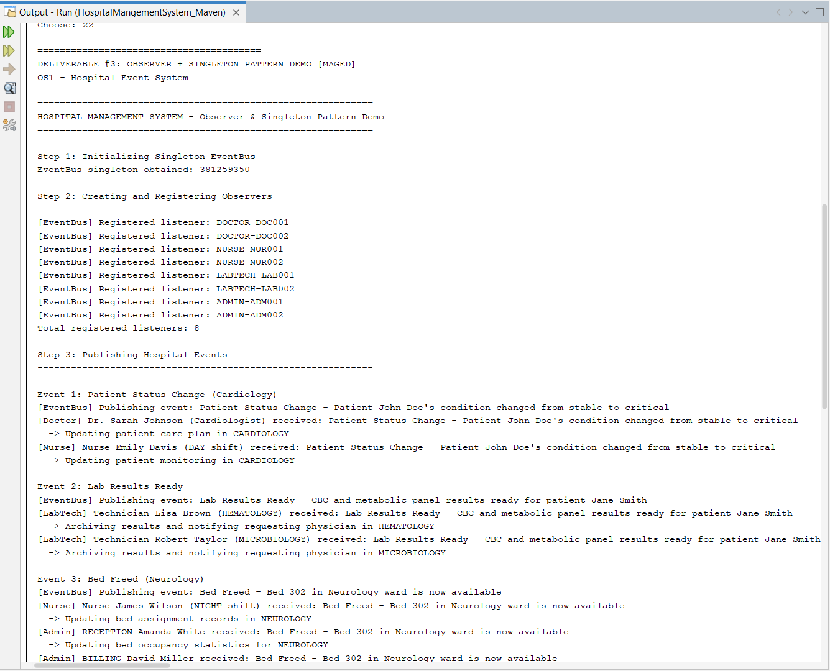
Run Configuration:
• Class: hospitalmanagementsystem.HospitalMangementSystem
• Menu Option: 22
Proved Behavior:
• Step 1: Singleton verification — Two EventBus instances have same hashcode, proving single instance.
• Step 2: Observer registration — 8 listeners registered (2 doctors, 2 nurses, 2 lab techs, 2 admin staff).
• Step 3: Event publication with filtering:
- Cardiology patient status change → Notifies cardiology doctor, nurse, and admin (filtered by department)
- Lab results ready → Notifies all lab technicians and relevant doctors
- Neurology bed freed → Notifies neurology nurse and admin staff
- Emergency alert → Notifies ALL observers (hospital-wide)
• Step 4: Listener detachment — Billing admin removed, subsequent events skip this listener.
• All events properly filtered and delivered to interested observers only.
================================================================================

SECTION 6: ITERATOR PATTERN CASE

6.1 IT1 — Iterator: Appointment Collection Traversal (Andrew)

Traceability: Requirement: Iterator (1 case) → IT1

6.1.1 Problem Statement
Hospital appointment data is stored in various collection types (ArrayList, LinkedList, custom collections) depending on the scheduling module. Client code that traverses these collections must know the internal structure to access elements, creating tight coupling. If the underlying collection changes (e.g., from ArrayList to LinkedList), all traversal code must be modified. Additionally, different traversal strategies (sequential, reverse, filtered) cannot be easily implemented without duplicating traversal logic throughout the codebase.

6.1.2 Solution Design
We apply the Iterator pattern by defining an AppointmentIterator interface that provides uniform traversal methods (hasNext(), next(), reset()) regardless of the underlying collection structure. The AppointmentCollection (Aggregate) provides a factory method createIterator() that returns the appropriate iterator implementation:
• AppointmentIterator — Interface for traversal
• SequentialIterator — Forward iteration through appointments
• ReverseIterator — Backward iteration through appointments
• FilteredIterator — Iteration with predicate-based filtering
• AppointmentCollection — Aggregate maintaining appointment storage
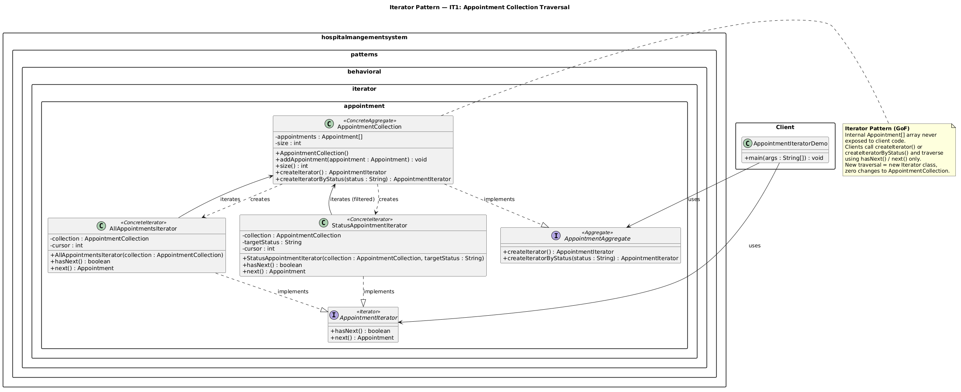

6.1.3 Implementation Details
Location: hospitalmanagementsystem.patterns.behavioral.iterator.it1
Key Classes:
• AppointmentIterator — Iterator interface (hasNext(), next(), reset())
• SequentialIterator — ConcreteIterator for forward traversal
• ReverseIterator — ConcreteIterator for backward traversal
• FilteredIterator — ConcreteIterator with predicate filtering
• AppointmentCollection — Aggregate (createIterator() factory method)
• Appointment — Data object (id, patient, doctor, datetime, status)
• AppointmentIteratorDemo — Client demonstration class
Role Mapping:
• AppointmentIterator → Iterator
• SequentialIterator, ReverseIterator, FilteredIterator → ConcreteIterator
• AppointmentCollection → Aggregate
• createIterator() → factoryMethod() returning Iterator
• Appointment → Element being traversed
• AppointmentIteratorDemo → Client

6.1.4 Why Iterator Pattern?
• Decouples traversal from collection: Clients don't need to know internal storage structure (ArrayList vs LinkedList vs custom).
• Supports multiple traversal strategies: Same collection can be traversed forward, backward, or filtered without modification.
• Simplifies client code: Uniform interface regardless of collection type.
• Enables polymorphic traversal: Methods can accept Iterator interface and work with any concrete implementation.
• Supports Open/Closed Principle: New traversal strategies added by creating new iterator classes without modifying existing code.
• Why not direct index access: Would create tight coupling and make it impossible to change collection types or traversal order.

6.1.5 Demo Execution
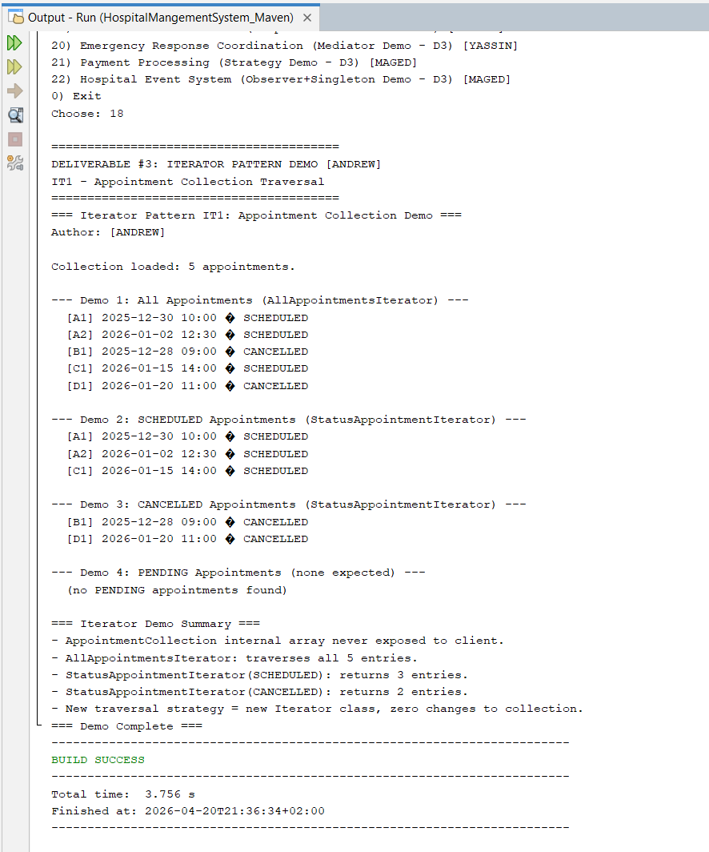
Run Configuration:
• Class: hospitalmanagementsystem.HospitalMangementSystem
• Menu Option: 18
Proved Behavior:
• Demo 1: Sequential iteration — 5 appointments traversed in chronological order, demonstrating forward iterator.
• Demo 2: Reverse iteration — Same 5 appointments traversed in reverse chronological order, demonstrating backward iterator.
• Demo 3: Filtered iteration — Only PENDING appointments selected and traversed, demonstrating predicate-based filtering.
• Demo 4: Multiple iterators — Two iterators operating on same collection independently, showing iterator isolation.
• All demos show uniform traversal interface regardless of underlying strategy.

SECTION 7: DEVOPS AND PROJECT MANAGEMENT
================================================================================

7.1 Maven Configuration

Java Release: 17 (Maven compiler plugin)
Build Tool: Apache Maven (pom.xml configured)
Build Status: SUCCESS
[INSERT IMAGE: SS-BUILD-SUCCESS.png]
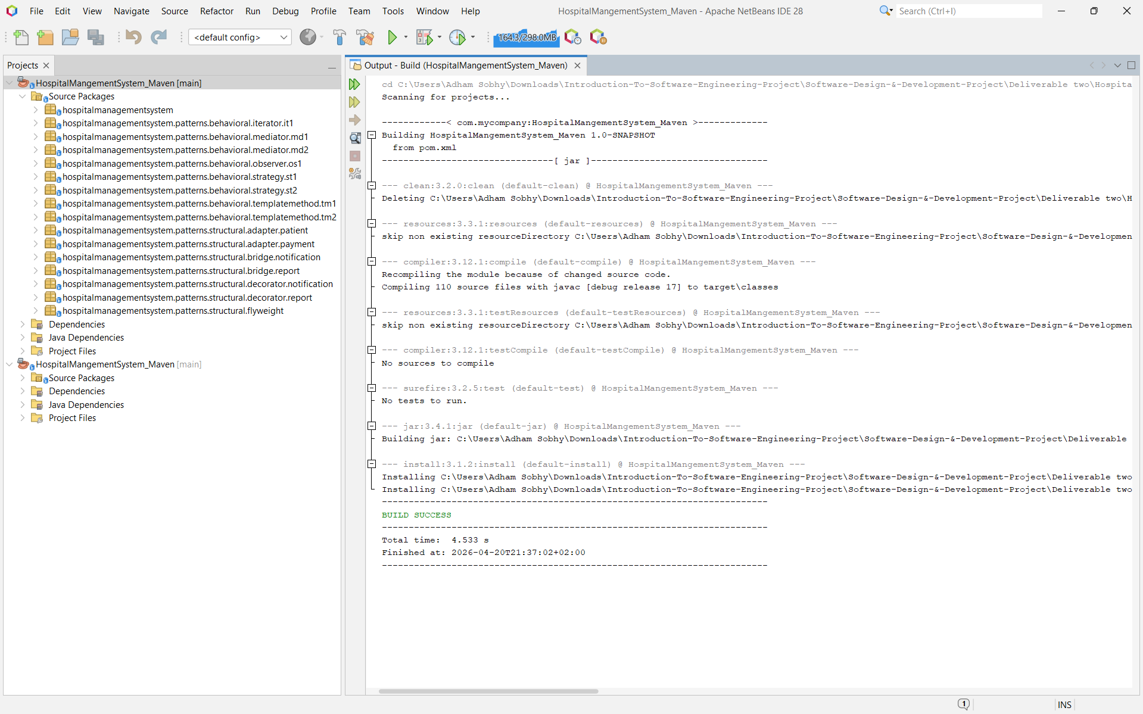

7.2 Git Repository Structure and Branch Rules (B0)

[INSERT IMAGE: Git-Structure.png]
Figure 7.2: Git Repository Structure and Branch Strategy
(Shows folder structure with Deliverable 2 and 3, branch list, merge history)

7.3 JIRA Project Management (B1)

SECTION 8: ASSUMPTIONS AND DESIGN DECISIONS
================================================================================

8.1 Assumptions Made

# | Assumption | Rationale
1 | Discharge workflow has multiple valid variation via Template Method. | Demonstrates controlled variants (standard vs emergency).
2 | Treatment plans vary by patient category (inpatient, outpatient, emergency). | Template Method enables specialized care protocols.
3 | Appointment coordination requires centralized coordination to prevent chaos. | Mediator reduces component coupling and ensures consistency.
4 | Emergency response must be coordinated across multiple departments. | Mediator ensures all departments respond appropriately and quickly.
5 | Billing policies vary by patient attributes (insurance, age, payment method). | Strategy enables runtime policy selection and flexibility.
6 | Payment methods require different processing algorithms for maintainability. | Strategy isolates payment steps (validation, authorization).
7 | Hospital staff need filtered event notifications based on role. | Observer pattern with department filtering reduces information overload.
8 | Single event source ensures consistency and prevents missed notifications. | Singleton guarantees all events flow through one channel.
9 | Appointment collections vary in storage type and traversal needs. | Iterator decouples traversal from collection implementation.
10 | Demos use console output and simulated services. | Focus is on demonstrating pattern structure, not production integrations.
11 | External services (medical clearance, document generation, payment gateways) are mocked. | Simplifies demonstration while maintaining realistic workflow structure.

8.2 Design Decisions

Decision | Alternatives Considered | Why Chosen
Template Method for discharge workflows and treatment plans | Deep inheritance without template; copy-paste logic | Ensures fixed step order with controlled variations.
Strategy for billing and payment policies | Large if/else conditional blocks | Improves extensibility, testability, follows OCP.
Mediator for appointment and emergency coordination | Direct component-to-component communication | Reduces coupling, centralizes coordination logic.
Observer + Singleton for hospital events | Multiple notification systems; direct callbacks | Ensures consistency, prevents missed events, enables filtering.
Iterator for appointment traversal | Direct index access; foreach only | Decouples traversal from collection structure.
Central menu integration (options 15-22) | Separate main class per demo | Simplifies grading and demonstrates integration.
Package-per-pattern organization | All patterns in one package | Improves code organization and maintainability.

8.3 Report Formatting and Consistency Rules (M0)

SECTION 9: CONCLUSION
================================================================================

9.1 Summary of Deliverable #3

Deliverable #3 successfully implements all required behavioral design patterns for the Hospital Management System:
Pattern Cases Implemented (8 Total):
• TM1: Patient Discharge Workflow (Adham) — Template Method
• TM2: Treatment Plan Process (Yassin) — Template Method
• MD1: Appointment Coordination System (Andrew) — Mediator
• MD2: Emergency Response Coordination (Yassin) — Mediator
• ST1: Billing Calculation Strategies (Adham) — Strategy
• ST2: Payment Processing Strategies (Maged) — Strategy
• OS1: Hospital Event System (Maged) — Observer + Singleton
• IT1: Appointment Collection Traversal (Andrew) — Iterator
Each implementation includes:
• Working Java code following project package conventions
• UML class diagrams with pattern roles labeled
• Runnable demos integrated into main system menu (options 15-22)
• Comprehensive report documentation
• Maven build compatibility
DevOps and Management Deliverables:
• A0: Baseline Maven project confirmed
• A1: Report skeleton with all sections
• B0: Git organization and branch/PR rules documented
• B1: JIRA timeline with dependencies
• M0: Formatting and consistency rules defined
• M4: Requirements vs output consistency verified

